Service Handbook
Exceptional Support for people
with intellectual disability

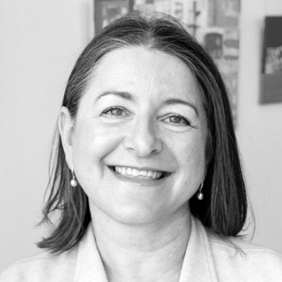
I am delighted to welcome everyone to Bayley House.
If you are new and need help with anything please reach out.
Be sure to say hello if ever you see me.
Deb Stuart CEO
Welcome to Bayley House Day Programs.
We help you to live a life with choice and control.
We listen to you to understand your goals, likes and interests.
We support you to achieve those goals and set new ones. Our activities help develop your skills.
Natarsha Warren
GM Day Programs
Supports to live the life we choose are very important to everyone.
We provide opportunities you to live independently. This can be in a group or shared accommodation.
Short Term Accommodation can also be provided for overnight or for several weeks.
Andy Gabriel
GM Home and Living Support

Bayley House is in Bayside, Melbourne.
We currently support over 250 people.
Our services include Day Programs, Transport, Support Coordination, Supported Accommodation, Short Term Accommodation, Community, Leisure and Recreation and more.
Bayley House has over 70 years’ experience
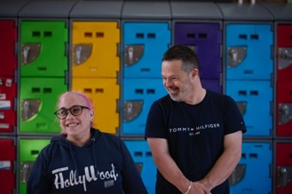
OUR VISION
For all people with intellectual disability to live a full and enriched life.

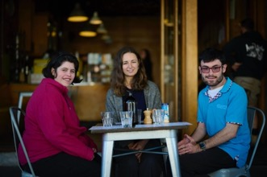
OUR VALUES
We provide exceptional services.
We actively support your goals and dreams.
We encourage and help you to have relationships with friends, family and the community.

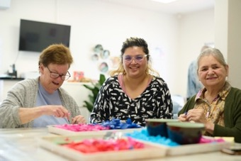
OUR STAFF
Bayley House employs over 200 staff in Home and Living Support, Client Services, Corporate Services, Day Programs, Finance, Fundraising, Human Resources, Marketing, Personal Care, Property Maintenance and Transport.
The Bayley House staff team have a lot of knowledge and experience.
Our staff team have training each year, to learn more about how to best support you.

OUR PROMISE TO YOU
Bayley House is committed to providing quality and safe services.
Bayley House provides supports that create positive experiences for the people who use them.
We are always improving what we offer.
We let you know what we are planning.
We have strong leaders.
We make sure that the services and supports we provide are safe, person-centred and respond to your needs, goals and choices.
We want you to let us know if you like or don’t like the way we do things. This is how we improve.

ANNUAL EVENTS
At the beginning of each year, we will give you a list that includes our holidays, public holidays and any major events we hold during the year.
All of this information is also on our website.

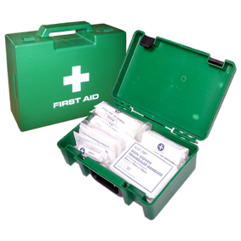
EMERGENCIES
All Bayley House buildings have an Emergency Response plan for any injuries and incidents.
We have fire drills and all buildings have signs and emergency fire equipment like fire extinguishers and fire blankets.
Our staff all receive training in First Aid and Fire Safety training.

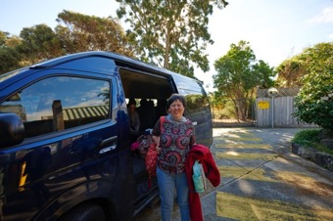
TRANSPORT SERVICE
Bayley House has a door-to-door transport service. Our transport zone map is on our website.
If you need to cancel your transport, please call your driver directly. The number will be given to you once you are allocated transport.

VOLUNTEERING WITH US
We have many opportunities to volunteer at Bayley House. Volunteering can be within our Day Programs, Corporate Services or events.
Contact our volunteer coordinator by emailing contactus@bayleyhouse.org.au

BAYLEY HOUSE AND THE NDIS
The National Disability Insurance Scheme (NDIS) is about you choosing how, when and where you receive the supports and services you need.
The National Disability Insurance Scheme (NDIS) is how you access and pay for the staff and support.
Bayley House is a registered service provider under the NDIS.
One of the goals of the NDIS is to give choice and control for people with a disability.
You can use more than one service provider at any time. If you are currently receiving services from another provider, you can also get services from Bayley House.

WHO TO CONTACT
Our campuses are open 8.30am - 4.30pm

Brighton Campus
52 Middle Crescent Brighton VIC 3186
dayservice@bayleyhouse.org.au
9982 1500

Hampton East Campus
928 Nepean Highway Hampton East VIC 3188
contactus@bayleyhouse.org.au
9982 1577

Bayley Arts
1 Avoca Street Highett VIC 3190
hello@bayleyarts.com.au
9113 0610
Home and Living Support
928 Nepean Highway Hampton East VIC 3188
agabriel@bayleyhouse.org.au
9982 1500

Operations Managers Home and Living Support
Astra Balzan
abalzan@bayleyhouse.org.au
0401 661 412

Kapil Bhatia
kbhatia@bayleyhouse.org.au
0401 668 977

Short Term Accommodation
Hampton East
Brighton
sta-bookings@bayleyhouse.org.au

Transport Service
Ray Fairley
rfairley@bayleyhouse.org.au
03 9982 1501

Client Services Team
clientservicesteam@bayleyhouse.org.au
9982 1515

IF YOU ARE AWAY
If you are going to be absent, please call 03 9982 1500 or email contactus@bayleyhouse.org.au
Following NDIS rules, services will be charged if we are given less than 48 hours’ notice of someone being away.

HOW TO FIND US

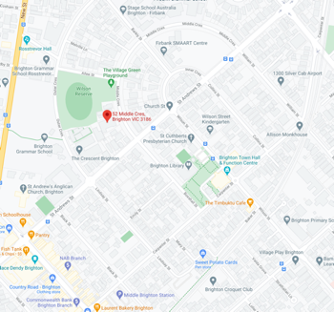
BRIGHTON CAMPUS
52 Middle Crescent Brighton
Our Brighton Campus is a short distance to Middle Brighton Train Station on the Sandringham Line. The closest main street is Church Street, Brighton.

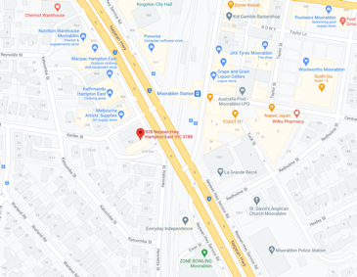
HAMPTON EAST CAMPUS
928 Nepean Highway Hampton East
Our Hampton East Campus is a short distance from Moorabbin Train Station on the Frankston Line. A pedestrian crossing with traffic lights is directly outside the train station.

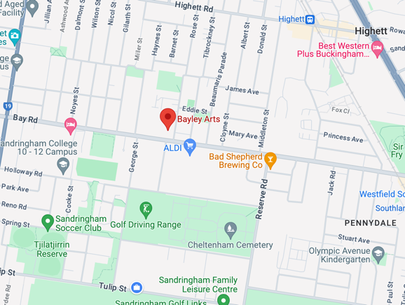
Bayley Arts
1 Avoca Street Highett

CLIENT SERVICES
The Client Services Team supports you with:
- Service Agreements: An agreement between each client and Bayley House.
- Schedule of Supports: Lists the supports Bayley House agrees to provide you with
- Accounts and Billing Enquiries
- Quotes: to take to your NDIS review meeting to make sure you receive enough funding
- NDIS Progress Reports: for you to take to your NDIS review meeting
- Enquiries about additional service availability
Please remember:
- Once you have a date for your NDIS review meeting, contact the Client Services Team so we can arrange a quote and NDIS progress reports for you
- Once you receive your new NDIS plan you need to tell us your new NDIS plan dates so we can create a new schedule of supports
- Always check your schedule of supports to make sure there is enough funding to pay for what you have asked for
- You need to provide us with your updated NDIS goals from your plan so we can make sure we are supporting you to work towards your goals
- If any other contact details change, please let us know
You can call the Client Services Team with any questions you might have.

9982 1515
clientservicesteam@bayleyhouse.org.au

YOUR FUNDING
It is your responsibility to make sure you have enough funds in your NDIS plan to build a Schedule of Supports.
A Schedule of Supports is the supports that will be provided and the costs of these supports.
Bayley House will provide you with a Schedule of Supports at the start of your NDIS plan (or when you join Bayley House).
If your supports need to change during the year we can help you with this and create a revised Schedule of Supports.

Suspension of Services
There might be times when we need to stop your services. We will always talk to you and try to work out any issues.
Suspension of services could be because of:
- Not paying for services
- All your NDIS funding has been used
Serious incidents which affect the wellbeing of other residents or staff
Your service agreement with us is not active
- Specialist management plans are not enough or up to date, for example: mobility or epilepsy plans

Support Prices
The prices for all of Bayley House’s services and supports follow the NDIS Price Guide.
NDIS prices are reviewed each year to make sure that you get value for money.
New price guides come out regularly and Bayley House follows these.
Bayley House charge for NDIS Supports and non NDIS Supports separately.
Each fortnight you will receive an invoice for the supports you received from Bayley House that are funded by the NDIS.
If you use a plan manager, we send the invoice to the plan manager for payment and send a copy to you for your records.

All NDIS Supports are listed in the NDIS Price guide on their website:
www.ndis.gov.au/providers/price-guides-and-pricing
On a separate invoice, each fortnight, you will be charged for your Non-NDIS Supports. These are your day activity fee and transport fees. These fees are paid from your own funds.
We divide the annual cost over 26 fortnights and charge every fortnight. You pay the same smaller amount each fortnight all year round.
Our pricelist for non NDIS Supports is on our website.

Billing Portal Queries
The Bayley House Billing Portal is safe and easy to use. You can view and pay your invoices here. We have a short video on our YouTube channel to explain how it works.
If you have any questions about your bills, you can call
9982 1515 or email myaccount@bayleyhouse.org.au

PRIVACY
We recognise, respect and maintain everyone’s right to privacy and confidentiality in all areas of their life.
- Your information is treated with respect and confidentiality
- We only need information that helps us provide supports and services to you
- We limit who can see your information
- Your information is shared only when you say so
- You have access to your information and we can help to explain it if you need us to
- You can ask us to update or correct any information
- Sometimes for legal reasons we have to share your information
- You decide who joins in meetings where your information is discussed
At Bayley House we need a Client Consent Form to be signed.
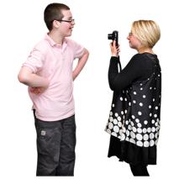
This form is to say yes or no to your image being used in any video, photography, digital and print based materials including text and audio. You can remove your consent at any time.
Our Mobile Phone Policy is for everyone at Bayley House. You are not to record anyone, in any way without their knowledge.
You can request a copy of any form or policy from a Bayley House staff member.

YOUR INFORMATION
We ask for personal information from you that we will securely store in our electronic system, Supportability.
This personal information helps us to know which supports you need and how you would like us to provide them to you.
Your personal support information and goals will be reviewed with you and/or your representatives every year and if needed we will help you to make new goals.
Your rights are protected by law. You have the same rights as other people in the community.

You have the right to:
- Live free from violence, exploitation, neglect, and abuse
- Be treated fairly and equally
Be treated as individuals
Honesty, respect, dignity, privacy
- Information and support to access services in the community
- To always be included in the services they receive
Quality services, that suit their needs and age
Support that respects their lifestyle and culture
- Make a complaint about the service and that complaint be resolved
- Have a support person, advocate or person of their choice to represent them when they want

You have a responsibility to:
- Respect other people’s rights to a safe, secure and comfortable environment
- Treat other clients, staff and volunteers with respect
Respect other people’s right to privacy and confidentiality
Assist staff to make sure everyone is safe and feels safe
- Respect the values and religious beliefs of others
Respect staff and their right to work free from abuse, rudeness, harassment and assault

BAYLEY HOUSE INDIVIDUALISED PLANNING
Before starting at Bayley House, a service agreement with a schedule of supports will be signed by you and Bayley House.
A Service Agreement helps everyone understand the services you need.
At your NDIS meeting goals are set. Bayley House matches you with activities that help you achieve your goals.
Staff monitor your progress towards your goals.

INCIDENTS AND MANDATORY REPORTING
Bayley House is committed to the safety and wellbeing of every person in our care.
If there are any issues at any time, please speak with a staff member as soon as you can.
Depending on the type of incident, we are required by law to notify organisation’s outside of Bayley House. This might include the police.

WHAT IS AN ADVOCATE
An advocate is an independent person who helps you express your views and wishes, and helps you stand up for your rights.
Advocates are there to support your choices.

WHERE TO FIND AN ADVOCATE:
VALID (Victorian Advocacy League for Individuals with Disability Inc.)
Free call: 1800 655 570
www.valid.org.au/
Provides advocacy support for adults with an intellectual disability across Victoria.
ADEC (Action on Disability in Ethnic Communities)
9480 7000
www.adec.org.au
A state-wide organisation that strives to empower people with a disability from non-English-speaking backgrounds, their carers, and families to fully participate as members of the Victorian community.
Consumer Affairs Victoria (CAV)
Helpline: 1300 558 181
www.consumer.vic.gov.au

Disability Resources Centre
(03) 9639 5807
www.daru.org.au
DARU is a dedicated resource unit funded to work with advocacy organisations to promote and protect the rights of people with a disability.
Office of the Public Advocate (OPA)
1300 309 337
www.publicadvocate.vic.gov.au
Provides guardianship and advocacy services for people with disability.
Villamanta Disability Rights Legal Service
legal@villamanta.org.au
www.villamanta.org.au
State-wide community legal service with primary focus on people with intellectual disability
Women with Disabilities Victoria (WDV)
9286 7800
www.wdv.org.au
Advocacy services on behalf of women with disabilities. For individual support or referral, please visit the WIRE website, Ph: 1300 134 130 or E: support@wire.org.au

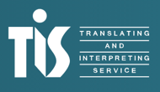
An interpreter service is available if you need one Interpreter Services 131 450 www.tisnational.gov.au

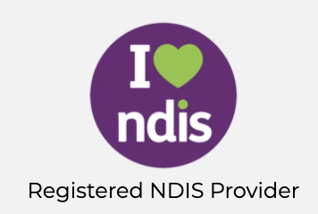
NDIS Quality & Safeguards Commission
Bayley House is registered as a service provider with the NDIS Quality & Safeguards Commission.
The Commission improves the quality and safety of NDIS supports and services.
The Commission make sure complaints are handled correctly.
You are protected by the NDIS Code of Conduct. The NDIS Code of Conduct is available on our website.

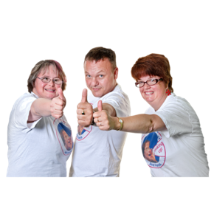

OUR DUTY OF CARE
Duty of Care is the way Bayley House staff must act under the law. This makes sure that no one is at risk of being harmed.
Staff behaviour is a big part of the support we provide. Staff must support you in ways that are respectful, supportive, and meet their duty of care responsibilities.

MEDICATION INFORMATION
Any medication that you may need to take while at Bayley House must be supplied in either a chemist Webster Pak or its original chemist labelled container
You must have a current doctor’s medication authority for any medication you need to take at Bayley House.
You need to tell us any medication you are taking, even at home.
Bayley House will give you medication forms for your doctor to fill out. We need to have your medication forms before you start with us.
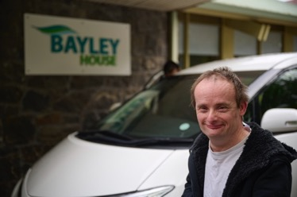
DAY PROGRAMS
Day Programs run from our Brighton Campus and Hampton East Campus. We use of community facilities for some activities.
Your activity locations will be listed on your timetable. A full list of our activities can be found on our website.
You choose your activities each year. Staff will discuss any changes you would like to make to your timetable during your annual review. A timetable will then be created for you.

DAY PROGRAMS LOCKERS
You will be given with a locker to keep your personal things in while you are at Bayley House Day Programs. You will be given a key for your locker. These lockers fit 1 backpack.

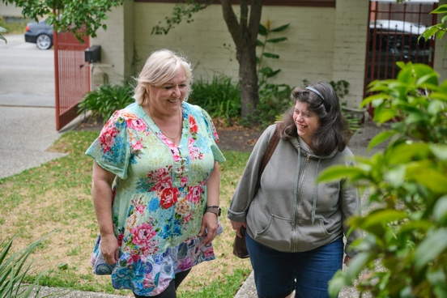
Home and Living Supports
Home and Living Support Service has accommodation options for people who need support in daily living. We offer:
- In-Home Support Service
- Supported Independent Living
- Specialist Disability Accommodation
- Medium Term Accommodation
- Short Term Accommodation

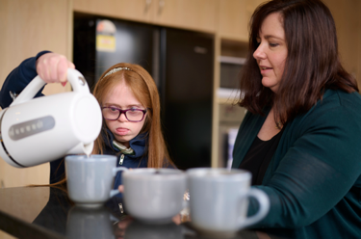
Short Term Accommodation - Respite
Bayley House has two Short Term houses that have five bedrooms.
When you stay with us you can make new friends and try new things.
You may choose to stay during the week, weekends or on holidays.
You can call us or email us
9982 1538
sta-bookings@bayleyhouse.org.au www.bayleyhouse.org.au/short-term-accommodation/

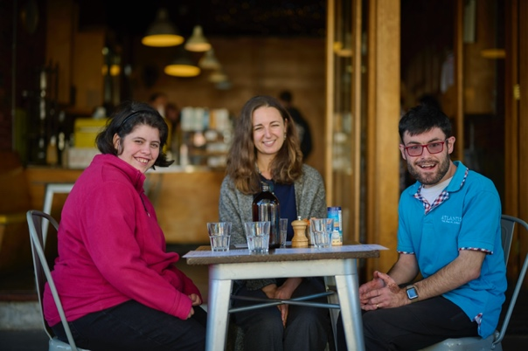
After Hours
Oue Community, Leisure and Recreation program provides opportunities to be social, learn new skills, get out and about in the community. We offer:
- Weekday Afternoons
- Weekends
- Holiday Activities
- Online Programs

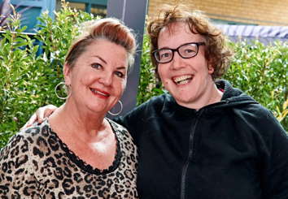
SUPPORT COORDINATION
Bayley House provides Support Coordination to current clients and people within the community.
Support Coordination provides options so that you can choose what works best for you and choose the support you need.

POSITIVE BEHAVIOUR SUPPORT
We provide Positive Behaviour Support to adults with intellectual disability who have behaviours stop them from enjoying their lives.

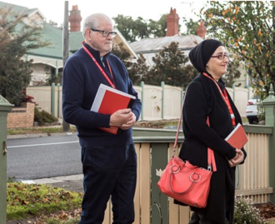
WHAT IS A COMMUNITY VISITOR?
Community Visitors are volunteers authorised by the Office of the Public Advocate to visit you and to make everything is ok in your home. A community visitor can visit your residence at any time, with or without notice.
You can contact Office of the Public Advocate to make a complaint or arrange for a visit by a community visitor on:
1300 309 337
opa_advice@justice.vic.gov.au www.publicadvocate.vic.gov.au/our-services/community-visitors

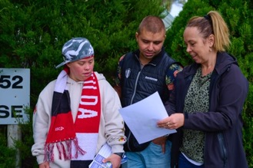
CONFLICT OF INTEREST
A Conflict of Interest is when someone from Bayley House tries to change your mind because they work for Bayley House. Our staff should help you make choices that are best for you.
You are entitled to know if the services you receive from us act independently and in your interests.
Bayley House staff will:
- Give you all the information you need to make a choice
- Tell you about all providers that have a support or service that you are interested in
- Help you find someone who can help you make a choice, this is an advocate or support person
- Make sure our staff understand their role is to help you make choices that are the best for you
More information on Conflict of Interest is available on our website.

